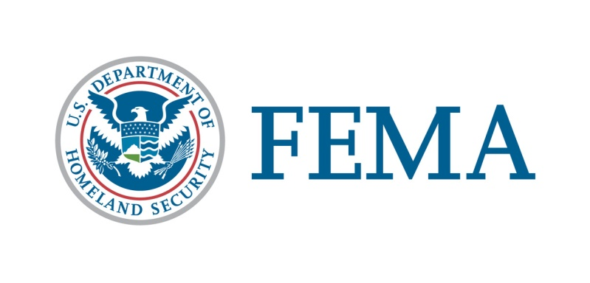

##### Congressional Affairs Division

202-646-4500

**State of New Mexico**

**Federal Disaster Declaration Fact Sheet**

**May 4, 2022**

Today, May 4, 2022, President Joseph R. Biden Jr., granted a Major Disaster Declaration for the State of New Mexico triggering the release of Federal funds to help people and communities recover from Wildfires and Straight-line Winds that began April 5, 2022, and continuing. Details of the disaster declaration and assistance programs are as follows:

Declaration Number:                                                           FEMA-4652-DR

Incident:                                                                              Wildfires and Straight-line Winds

Incident Period:                                                                   April 5, 2022, and continuing

Federal Coordinating Officer:                                           Sandra L. Eslinger

                                                                                                National FCO Program

Individual Assistance (IA):                                                    (Assistance to individuals and households):

IA-Designated Counties:                                                       Colfax, Lincoln, Mora, San Miguel, and Valencia Counties.

Public Assistance (PA):(Assistance for emergency work and the repair or replacement of disaster-damaged facilities):

PA-Designated Counties:                                                       Colfax, Lincoln, Mora,

San Miguel, and Valencia Counties for emergency protective measures (Category B), limited to direct federal assistance and

reimbursement for mass care including evacuation and shelter support.

Hazard Mitigation (HM):                                                       (Assistance for actions taken to prevent or reduce long term risk to life and property from natural hazards):

HM-Designated Areas:                                                             All areas in the State of New Mexico are eligible to apply for assistance under the Hazard Mitigation Grant Program.

OTHER:                                                                                   Additional designations may be made at a later date if requested by the State and warranted by the results of further assessments.

Individuals in Colfax, Lincoln, Mora, San Miguel, and Valencia Counties can apply with FEMA the following ways:

* Apply online at [www.DisasterAssistance.gov](http://www.DisasterAssistance.gov).
* Constituents may call the application phone number at 1-800-621-3362. If you use a relay service, such as video relay service (VRS), captioned telephone service or others, give FEMA the number for that service.

###